

Software Project Guide

Semester Fall 2015

Created By,

Research and Development section,

Department of Computer Science,

Virtual University of Pakistan

**Table of contents:**

|  |  |
| --- | --- |
| **Topics** | **Pageno.** |
| 1. What is a software project? | 3 |
| 1. Purpose of a software project | 3 |
| 1. Should I take software project? | 4 |
| 1. Eligibility Criteria | 4 |
| 1. Guidelines to register for a Project | 4 |
| 1. Grading Policy | 4 |
| 7. Software Projects for Fall 2015 | 5 |
|  |  |

**Whom to Contact?**

This booklet provides comprehensive details to the students who are planning to take Software development projects as their final projects. Therefore, such students are advised to go through it in complete.

If any of the quires are unsatisfied even after having read the information given in rest of the booklet then students should contact to **concerned supervisor**.

**1.** **What is a Software Project?**

At first it is important to understand what the software is? “Software” can be defined comprehensively as,

[1]“Computer Programs that, when executed provide desired function and performance, data structures that enable the programs to adequately manipulate information and documents that describe the operation and use of programs”.

Looking at the definition indicates clearly that developing software does not mean mere development of programs (or code) rather it requires the related documents to be produced as well.

To develop software effectively requires following a process. Each stage of this process culminates in one or more artifacts.

Examples of software projects are, software developed for face recognition, building a Customer Relationship Management (CRM) System, Flight Simulation System, Point of Sale (PoS) System, a Web Portal,an Electronic Store Front etc.

Software projects can be aimed at producing a desktop application, an embedded application (like to be used in microwave oven) or some online application.

**2. Purpose of a Software Project:**

The University aims at producing such IT professionals who leave the impression of excellence in knowledge and skills in their professional lives. Students are encouraged to come up with innovative and unexplored ideas while addressing a problem.

After having completed the project students will be expected to have the following skills,

* It will provide the students with an opportunity to implement the concepts they have learned throughout their degree program so far.
* Awareness of the latest technologies being used in the industry and more importantly the application of those technologies.
* Knowledge of all the formalities required to undertake asoftware project.
* Enough confidence to take the challenges of their practical environment.

**3. Should I take Software Project?**

The development project is recommended for those students who have an aptitude and interest (equally important) for development. Presence of analytical skills to solve a problem is also highly requisite. If a student finds these ingredients in himself/herself then deficiencies (to a certain extent) in the areas like programming, data base and software engineering etc can be overcome but such a student will have to put extra efforts (depending upon the deficiencies) to make his/her weak areas stronger. A shaving ambitions only does not lead to the goal, one has to strive for those ambitions to get them materialized.

**4. Eligibility Criteria**

* No student below 1.75Effective CGPA will be allowed to take the project title.
* MCS/MIT Students must have completed 30 credit hours to become eligible for taking the final project. So don’t enroll in CS619 course or drop your cs619 course if you have earned less than 30 credit hours.
* BSCS/BSIT Students must have completed 90 credit hours to become eligible for taking the final project. So don’t enroll in CS619 course or drop your cs619 course if you earned less than 90 credit hours.

**5. Guidelines to register for a Project**

Please read the following to get to know, how you can get registered for you final project.

* First of all, you have to enroll in CS619 course in Fall 2015 semester through course selection (contact [course_selection@vu.edu.pk](mailto:course_selection@vu.edu.pk) for enrollment).
* Carefully read the eligibility criteria and only send a request if you are eligible to take a final project title. Otherwise drop your cs619 course. The project selection will be done through LMS.
* Students will be required to make groups. In a group maximum two (2) students are allowed.
* A student can also choose to do the project alone (a single member of the group instead of two)
* Students who fail to submit their final project in specified duration (two consecutive semesters) will need to take course CS619 in extra semester to continue the same project.

**6. Grading Policy**

Students will be clearly communicated about the deliverables they need to submit on specified dates. This is important to remember that each deliverable carries a significant weightage so students are advised to take each deliverable very seriously and submit it according to the date announcements according to the submission schedule.

While evaluating the students the following factors will be considered important

* Effective use of time and of visual aids.
* Organizational and presentation skills.
* Seriousness and dedication of the students in meeting the announced dates for each deliverable.

**7. Software Projectsfor Fall 2015**

Following is the list of projects which have been offered for Fall 2015.

Students can only select a project from this given list.

Students have to adhere to the requirements specified with each project as the evaluation of the executable artifact will be performed accordingly.

Next, each offered project’s detailed information is provided.

**Ultimate SMS Blocker**

This system will assist users to get rid of unwanted SMS in unmatchable way. The mobile app will allow following features to users, that are either not yet available freely in any single app or the app is not free:

* Manage block list (add, update, remove a number or name).
* If user chooses ‘Add to block list’ feature, the application will show all existing SMS in user’s inbox, from which user can select one or more SMS messages for blocking. On proceeding to next step, the application shall add all selected SMS senders’ numbers [or names in case number cannot be extracted] in the block list.
* Once a number or name is in the block list, any future SMS will not be delivered to user’s inbox, but each blocked SMS will be maintained for a certain period of time by the application as defined by user.
* The block list will have following menu options:
  + Number of days to keep a blocked SMS in the list [user will specify no. of days from 1 to 1000], after which the SMS will be automatically deleted;
  + Move to Inbox [user can select one or more SMS to move to inbox];
  + Remove from block list [future SMS shall not be blocked]
* Export blocked list in multiple formats [text, XML file, CSV file etc.]. On export, the application shall save the file to a specific location, and show a message to user indicating where it is going to be saved.
* Import block list [all imported numbers or names will be added to existing block list].
* Add series to block list [e.g. 111 to 114 will add four numbers to block list: 111, 112, 113, 114].
* Sort block list date wise [the date when added to blocked list], or number wise, or name wise.
* Option to block unknown numbers [so the app will only allow the SMS that is not in blocked list and the sender’s number or name is added in mobile contacts].

**NOTE** For android KitKat 4.4 and above, only one application can handle SMS, so the students who are planning to develop this project in Android, must ensure they are using earlier versions then KitKat 4.4 in their development or testing environments.

**Tools:** Development environments / IDEs for any one of the following:

* + Microsoft.Net
  + Android
  + iOS

**Supervisor Name:** Usman Waheed

**Email ID:** [usman.waheed@vu.edu.pk](mailto:usman.waheed@vu.edu.pk)

**Graphical password or Graphical user authentication (GUA)**

Access to computer systems is most often based on the use of alphanumeric passwords. However, users have difficulty remembering a password that is long and random-appearing. Instead of long password user can create short, simple, butinsecure passwords.

Graphical passwords have been designed to try to make passwords more memorable and easier for people to use and, therefore, more secure. Using a graphical password, users click on images rather than type alphanumeric characters.A graphical password is an authentication system that works by having the user select from images, in a specific order, presented in a graphical user interface (GUI).

* User will add personal information in signup page.
* User will upload 4 to 6 images in sequence.
* These uploaded images in order will be act like password.
* In Login page, Admin will generate more than 30 images including the user’s uploaded images.
* Admin will use library of images to include randomly generated images on user’s login interface.
* User will select in sequence uploaded images from the login interface.
* User can change his password.
* User will get login after successfully selection of uploaded images in sequence.
* Admin will keep record of all login history of each user.

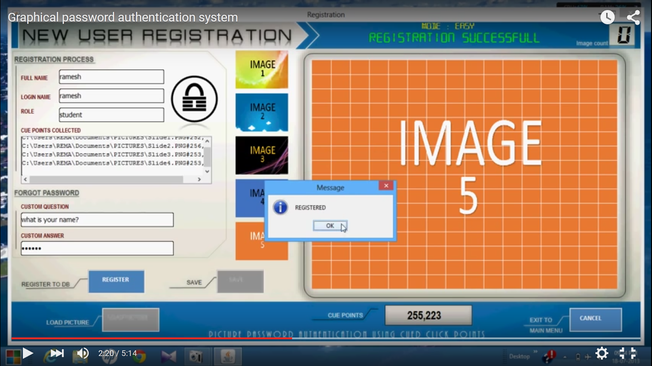

**Supervisor Name:** Shakeel Saeed

**Email ID:** [shakeel@vu.edu.pk](mailto:shakeel@vu.edu.pk)

**“Smart ETL Tool”**

It is a desktop application which enables the user to map multiple databases to a DWH in a DBMS. Extract, Transform and Load (**ETL**) is a process used in Data Warehouse. This process Extracts the data from multiple sources, Transforms the data for storing it in proper format/structure and then Load in to DWH.

**Prerequisites:**

Students should have good concepts of databases (CS403) and Data Warehouse (CS614)

**Requirements:**

1. The user will first select the database/databases and DWH for mapping.
2. The software will show the summery to the user regarding the structure and metadata of the databases as well as of the DWH.
3. The software will provide the facility to the user to map the different tables and columns of database (s) to the tables and columns of DWH.
4. The software should provide the facility to extract the data from multiple databases.
   1. Extraction can be of the following types.
      1. Full Extraction
      2. Incremental Extraction
5. The software should provide the facility to transform the data.
   1. The user can select any type of transformation from the following (one or more)
      1. Splitting/Joining
      2. Conversion
      3. Summarization
      4. Enrichment
6. The software should provide the facility to load the data in to DWH.
   1. The user can select any type of loading from the following
      1. Full data refresh
      2. Incremental data refresh
      3. Trickle/continuous feed

**Tools:** Java/net Framework And Sql server

**Supervisor Name:** Shabib Aftab

**Email ID:** [shabib.aftab@vu.edu.pk](mailto:shabib.aftab@vu.edu.pk)

**SIT (Step-in Security)**

There is an organization which has more than five hundred staff. The organization has a colony for staff accommodation. The organization provides all facilities including security to the residents of the colony. Strict rules are being followed to provide maximum security to the residents. Nobody is allowed to enter or exit the colony without intimating the security staff.

Security staff issues ID cards to Staff and their family members. Security staff keeps record about entrance or exist of employees and their family members from the colony.

A proper record of guests who wants to visit any resident of the colony is maintained. Guest shows NIC (National Identify Card) to the security staff who note down guest’s credentials from CNIC and issue visitor pass to the guest after keeping his/her CNIC which will be returned when guest leave the colony. If the guest has any vehicle then its number will also be recorded. The names of those who are accompanying the guest are also being recorded. Guests are not allowed for night stay in the colony until permission is obtained from the Security Officer. A written application having a duration for which that guest will stay in the colony is given to the Security Officer who approves the application and mark to the security staff for issuance of Visitor’s pass for this duration to the guest. Each guest will return the visitor pass at the time of leaving the colony and collect CNIC from security staff.

There are separate schools for girls and boys. Children from outside the colony also come to study in those schools. Entry/exit record of children and school staff is maintained on daily basis.

Official vehicles of the organization are also be parked in the colony. Proper entry/exit record of those vehicles along with the driver info is being maintained.

I mentioned a manual system which the security staff has adopted for record keeping. You are required to develop a client server application to automate this manual process.

Note: During issuance of visitor pass process, if CNIC data is already in the system then that data should be populated automatically to reduce the data entry.

**Reports**

1. Daily Visitor Report with a provision for particular duration
2. Guest Report Employee Wise
3. Report of a Guest to whom he/she has visited
4. Visitors who did not returned their Visitor Pass
5. Visitor who did not obtained night stay permission
6. Employee List
7. School Staff List
8. Student List
9. Daily Report of the school
10. Vehicle Daily Entry/Exit report with a provision for a particular duration

**Supervisor Name:** Sarfraz Ahmad

**Email ID:** [sawan@vu.edu.pk](mailto:sawan@vu.edu.pk)

1. This definition is taken from the book “Software Engineering A Practitioner’s Approach (Fourth Edition) by Roger S. Pressman”